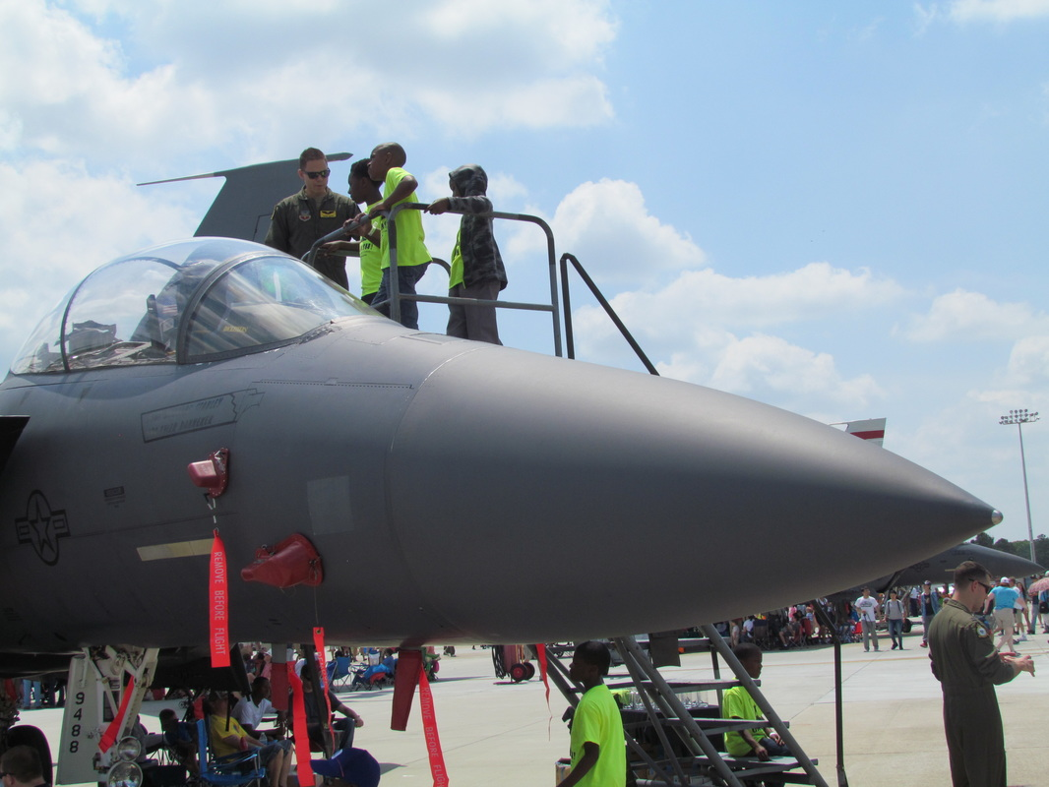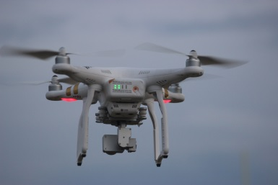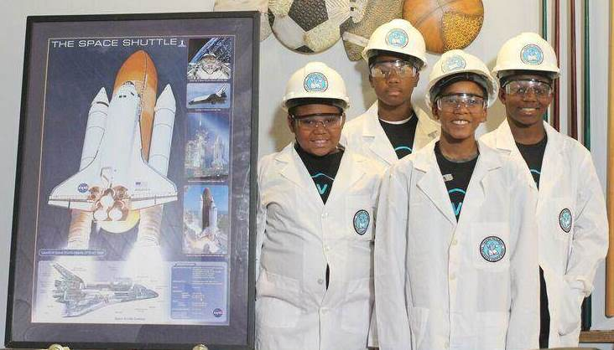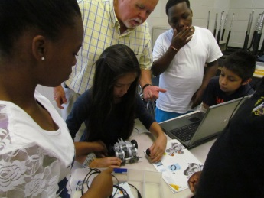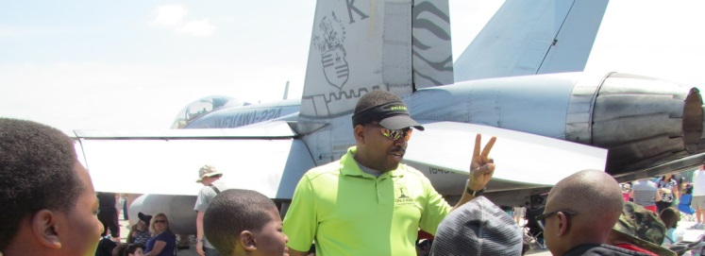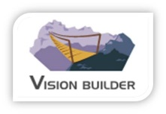

***THE 5 WEEKEND S.T.E.M. PROGRAM***

**SCIENCE- TECHNOLOGY- ENGINEERING- MATHEMATICS**

Our weekend program offers project based student- centered learning STEM classes. This program introduces youth ages 9-13 to professions in STEM fields. We help plan and deliver a project program that encourages youth to think like Engineers/scientist.

**Program STEM fields:**

**Aerodynamics –Aeronautics –Buoyancy Robotics -Structure Design -Chemistry**

Apply online **ASAP** for March or May classes!

For more information go to: ***www.visionbuilder.org***

o

o

This program we offer our partners give our partners a platform to build off of.  They can teach life skill classes off of it.  And they can introduce more STEM Engineering activities.

**TRY STEM!**

**A better future career option for youth!**

www.visionbuilder.org

INSPIRING YOUTH TO see beyond where they are!

[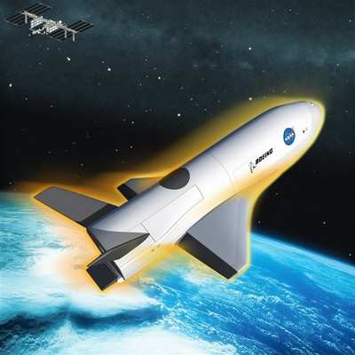](http://www.google.com/url?sa=i&rct=j&q=&esrc=s&source=images&cd=&cad=rja&uact=8&ved=0ahUKEwjk78GX1cnRAhXK2SYKHdM9A7UQjRwIBw&url=http://www.aero-news.net/index.cfm?do%3Dmain.textpost%26id%3Dac45e07e-3a53-47aa-9892-fe87c756e28e&psig=AFQjCNEEfawKu2SQwnl_w0RL1rlrFD1xhA&ust=1484759139669105)G YOUTH TO see beyond where they are!

### VISION BUILDER ADVENTURES

# Click here to enter text.