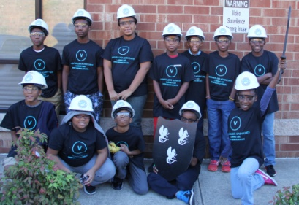

STEM Project Parents,

Please advise your friends and families about the 5 Weekend STEM program. The program starts Saturday, March 4, 2017. We will be adding two more companies to your Battalion. (BRAVO and CHARLIE) Program Cost is $150 for 5 weeks. ($25 Application fee will be waived if you apply before February 1, 2017)
Price now: $125

- Parent information session will be Saturday, February 25, 2017. (TTBA)
  - Mclean Road Baptist Church
    - 1800 McLean Rd,
    - Charlotte, NC 28213
- Other program locations per companies.
Arrowhead Business Park
    - 200 Arrowhead Dr. E,
    - Charlotte, NC 28213
Huntersville Aquatic Center
    - 11725 Verhoeff Dr.
    - Huntersville, NC 28078
- Thank you parents for allowing your youth to learn with us.
Visit www.visionbuilder.org for more information.

