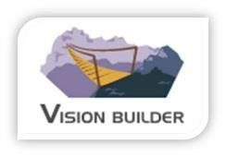
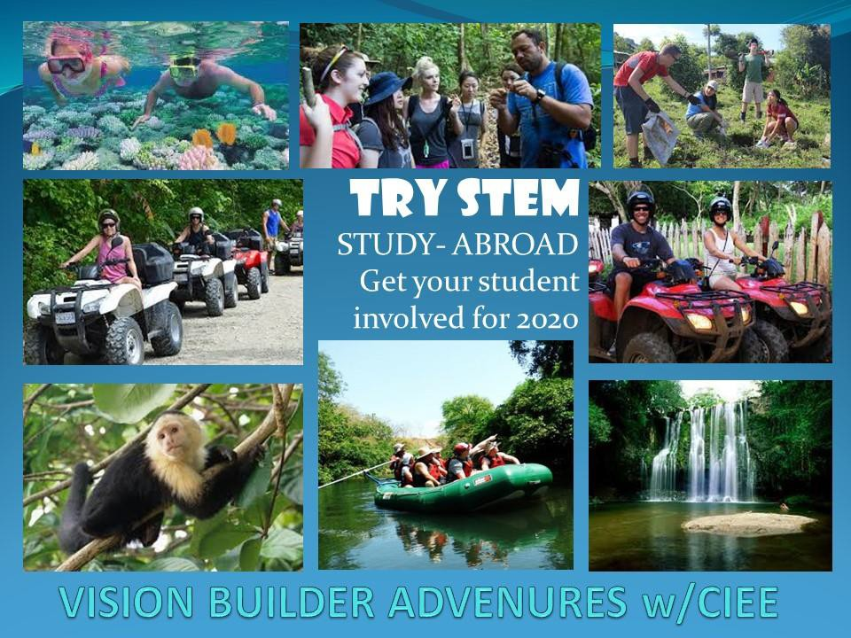
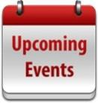
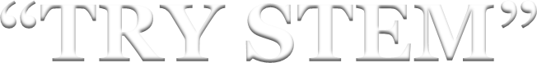
www.visionbuilder.org

New Fall STEM class projects for 2017
The Latest News

Vision Builder Adventures

This email is being sent to all associates, and friends of Vision Builder Adventures.

This E-news Blast will be sent throughout the Summer making you aware of past activities and future events.
Great News!! We are preparing to study STEM abroad in 2020:

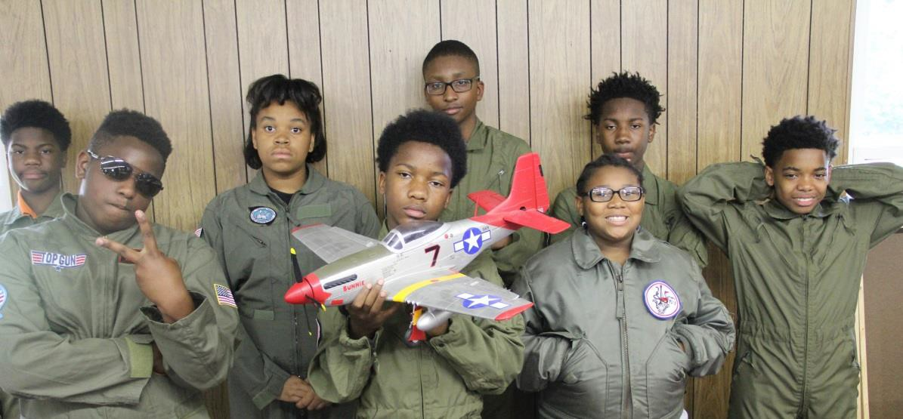

An opportunity has a risen with our community partner (CIEE) to send some of our
Students abroad to study STEM in 2020. (We have 3 years to prepare the students. Interested parents please sign up for interest meeting is late September.)

Some general information

- Students will need to be in High School at the time of departure.
- Students will spend 7 -days in a foreign country.
- In the host country students will learn to speak survival language for the country. (French or Spanish)
- In the host country students will study hand on science. (Earth, Physical and Biology)
- In the host country students will help teacher with local classes.
- In the host country students will learn about the culture.
Budgets are Due!! Don’t forget to add STEM to your curriculums this Fall:
The Camp season is just about over. We are launching Rockets, Catapults, flying Planes, building Boats, programming Robots and unleashing other STEM related classes. We are starting to schedule class projects for Enrichment Programs for the Fall session of

2017. The following class projects will be in Mecklenburg and surrounding counties. Classes will Include:

- Introduction to Rocketry Program
- Exploratory Robotics Program
- Buoyancy and Water Displacement
- The science of the Catapult
- Basic & 101 Aerodynamics
- Exploring structure & design
- Aeronautics Design
- Forensic Science
- Understanding Electricity

We still have the following classes in session as well:

- Leadership 101
- The Power of Choices
- Rediscovering America classes
“Congratulation” to our resident BMX pro William Murray:
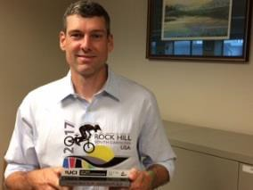

The BMX World Championships
Congratulations to William Murray, one of our Charlotte community partners. (He has been working with our students for 6 years.) He is competing in the BMX World Championships. William Murray beat out 72 other riders to qualify for the Championship round. He will compete for the World Championship this Friday. He is 1 of 8 going for the title "Best in the

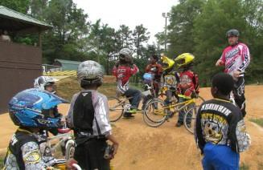
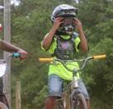
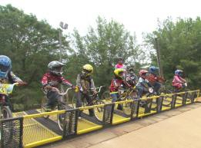
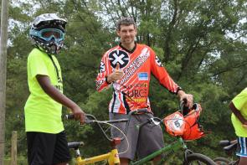
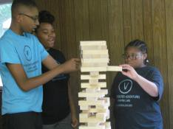
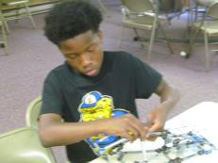
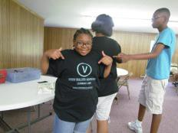
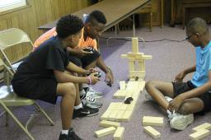
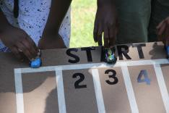
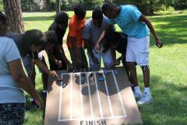
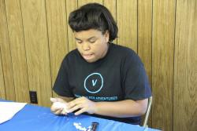
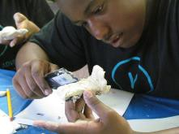
World". If you are in Rock Hill S.C. or surrounding cities, come out and cheer him on. Contact us for additional information if you would like to attend.

Some “UNLEASH” BMX Event pictures with William Murray.

Our STEM Program
VBA serves to inspire kids through the exploration of science, technology, engineering, and mathematics. (STEM) Through our hands on activities, kids explore, ask question, persist and solve problems. By interacting and working with people in STEM careers, kids come to view these careers as exciting and realistic options for themselves. VBA STEM is an approach that each organization can apply to its own programming. VBA may also implement one or more of the following components that have been built around the VBA STEM philosophy. (Dare to Dream)

VBA STEM- Our STEM classes are project based student- centered learning. This program introduces kids ages 9-17 with professions in STEM fields. We help plan and deliver a project program that encourages kids to think like scientists.

VBA Program: "REWIND" STEM SUMMER CAMP FUN
Please check out some of our fun videos online.

Some Structural Design classes pictures

Some Structural Design clay car racing class pictures

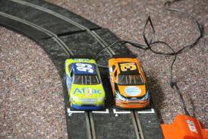
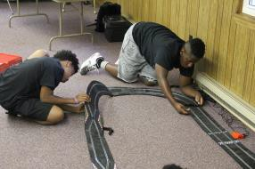
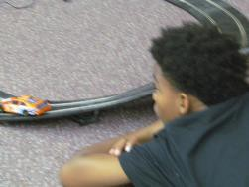
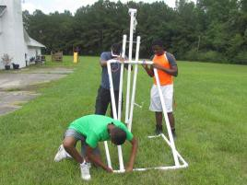
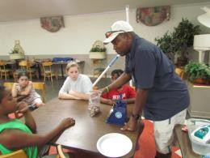
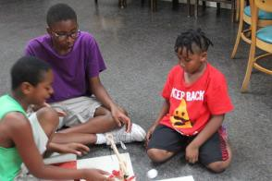
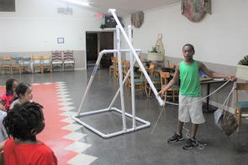
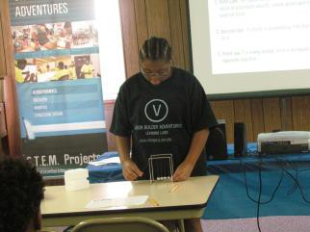
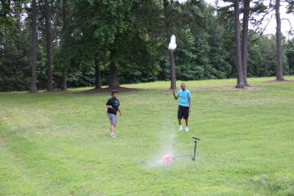
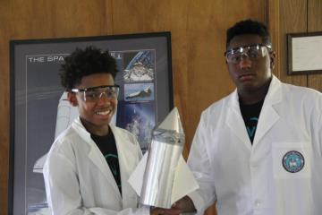
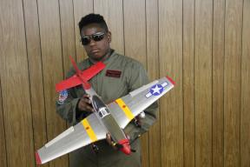
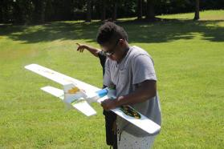
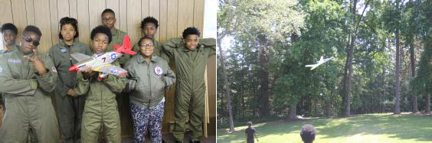
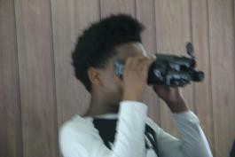
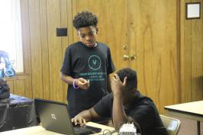
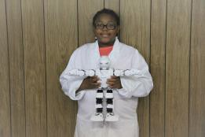
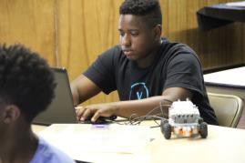
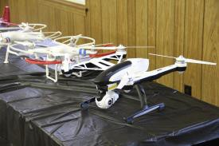
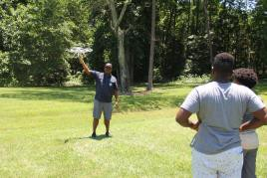
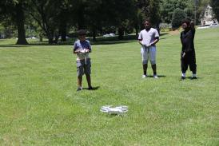
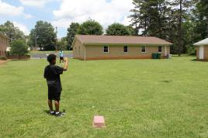

Some Electricity AC/DC current class pictures

Some Catapult class pictures

Some Rocketry class pictures.

Some Aerodynamic class pictures.

Some Robotics class pictures.

Drones 101 class

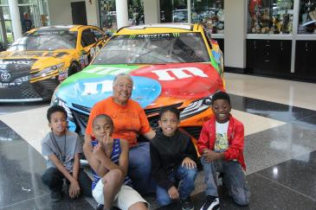
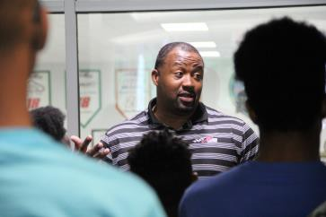
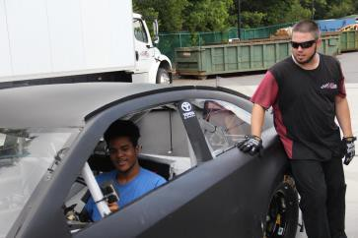
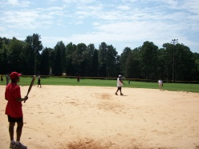
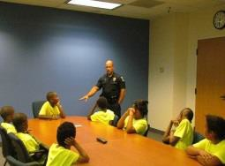
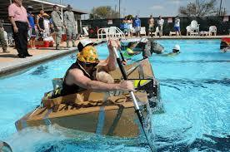
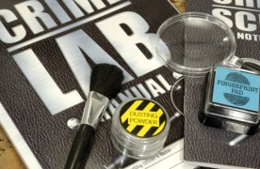

Sign your Youth organizations up today! Go to www.visionbuilder.org to schedule (or) for more info.
Special thanks to all the programs and activities partners:

Joe Gibbs Racing Experience.
Special thanks to all organizations who participated with Vision Builder Adventures over the last two months.
- Please note: we are working to meet the needs of all interested programs across the state. We are currently scheduling for fall 2017, let us know how we can serve you in future.
Some 2017 upcoming projects: "Sign your Youth organizations up
today”

Some upcoming events for 2017.

Some upcoming events and classes include:

August 2017
- Back to school prep programming, Wake and surrounding Counties.

September 2017
- Friends and Family picnic/Softball game (please RSVP)
- Afterschool programming, Mecklenburg and surrounding Counties.
- 9-week “Speak up Program”, Mecklenburg and surrounding Counties.
- 5- Weekend STEM Labs, Mecklenburg and surrounding Counties.

October 2017
- Afterschool programming, Mecklenburg and surrounding Counties.
- 9-week “Speak up Program”, Mecklenburg and surrounding Counties.
- 5- Weekend STEM Labs, Mecklenburg and surrounding Counties.
November 2017
- Afterschool programming, Mecklenburg and surrounding Counties.
- 9-week “Speak up Program”, Mecklenburg and surrounding Counties.
- 5- Weekend STEM Labs, Mecklenburg and surrounding Counties.
December 2017
- Afterschool programming, Mecklenburg and surrounding Counties.
- 9-week “Speak up Program”, Mecklenburg and surrounding Counties.
- 1st Annual Boat Race, Mecklenburg and surrounding Counties.

Go to www.visionbuider.org to see additional pics of events and classes.

