T-Shirt Order Form
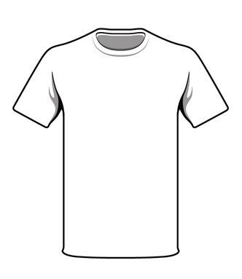
Note: All shirts have the same Logo.

Student Name: ___________________________________________________
Program Director: _________________________________________________
Parent name: ____________________________________________________
Email address: ____________________________________________________
Contact Phone numbers: ________________________ Check#: ____________
Short Sleeve Tee shirt- $10 (Please indicate the quantity size: _____ )

Small _____ Medium _____ Large ______ X-Large _____ 2X-Large ______

